Email:loverealmglobal@yahoo.com

Your Ref: Date: {{dateDay}}{{daySuffix}} {{dateMonthUpper}}, {{dateYear}}

THE CHIEF EXECUTIVE OFFICER
GLICO GENERAL INSURANCE
ACCRA

Dear Sir,
APPLICATION FOR A BID SECURITY
We should be grateful if you would issue us a Bid Security in favour of {{hospitalName}} to enable us bid for a tender with details below:

NAME OF CONTRACT: THE {{titleUpper}}

IFT NUMBER: {{sqNumber}}

SUBMISSION DATE: {{dateDay}}{{daySuffix}} {{dateMonthUpper}}, {{dateYear}}

VALIDITY PERIOD: {{validityTerms}}

BID BOND AMOUNT: GH¢ 10,000.00

PURCHASER ADDRESS: {{hospitalName}}

{{hospitalAddress}}

Yours faithfully,
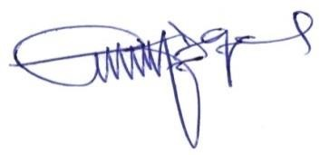

…………………………
S. D. ANSONG
MANAGING DIRECTOR

